Title: Community Service at Shri Navjivan Viklang Sevashray
Name of the Student: Khush Pithva
Roll No:24BCE174
Semester: 3rd
Name of Organization Community Services undertaken: Shri Navjivan Viklang Sevashray
Name of Contact Person: Mr. Jayeshbhai Rangadiya
Address: Dhrangadhra Road, Opp. 220 K.V Substation, GIDC Area, Halvad, Gujarat 363330
Telephone/Fax: 8980227705
E-mail: navjivan.halvad@gmail.com
Website: http://navjeevantrusts.org/

Details (in bulleted points) of Major Activities carried out by the Organization:
- Runs a school for children who are physically and/or mentally disabled.
- Provides basic education and daily life skill training to specially-abled students.
- Offers community outreach to locate and support people with disabilities.
- Assists families in obtaining disability cards and other government benefits.
- Provides emotional and social support to families of disabled individuals.
- Promotes awareness about inclusion and equal rights.
- Coordinates with government agencies for benefit schemes and disability pensions.
- Maintains records and profiles of special-needs individuals in the community.

Contact Details of Immediate Supervisor under whose guidance the activity was carried out:
Name: Mr. [Supervisor Name]
Contact: +91 [Phone Number]

Major activities/themes (in bulleted points only) on which organization works:
- Support and education for physically and mentally challenged children
- Inclusion and awareness for specially-abled individuals
- Government benefit facilitation (disability card, pensions, etc.)
- Community outreach and field visits
- Family guidance and emotional support
- Data collection and records maintenance
- Equal opportunity and rights for disabled individuals

Time Duration of Community Service Activity:
Date/s (including no. of hours): 25/05/25 to 14/06/25 (30 hours)

Location of Activity:
Offline, On-site at Dhrangadhra town, Surendranagar district, Gujarat, India

Aim of Activity:
The goal was to assist Shri Navjivan Viklang Sevashray in identifying and supporting individuals in the community who are physically or mentally challenged. It also aimed to spread awareness about the government schemes available to them and help them access these services by guiding them through the process of acquiring a disability card.

Specific Task/s carried out:
- Visited various homes in Dhrangadhra to collect data about physically or mentally disabled individuals.
- Identified more than 80 people over a span of 21 days.
- Interacted with the families to understand their living conditions and needs.
- Informed them about government schemes and benefits such as disability pension, free transport, and subsidized healthcare.
- Explained the importance and usage of the disability ID card.
- Provided guidance on how to apply for the disability card and what documents are required.
- Recorded data in a structured format for organizational follow-up.
- Participated in awareness drives conducted by the NGO.

Photos (with title) of Activity:
(Attach relevant photos under these suggested titles)

- Field Visit in Dhrangadhra
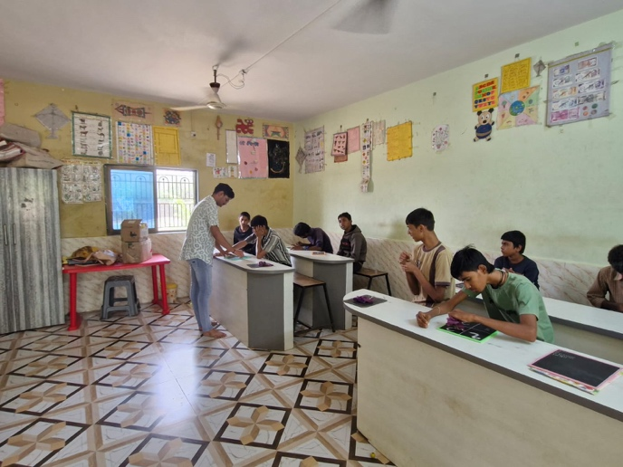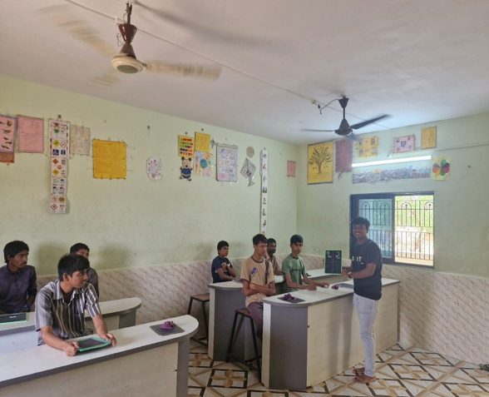
- Interacting with Families of Disabled Children
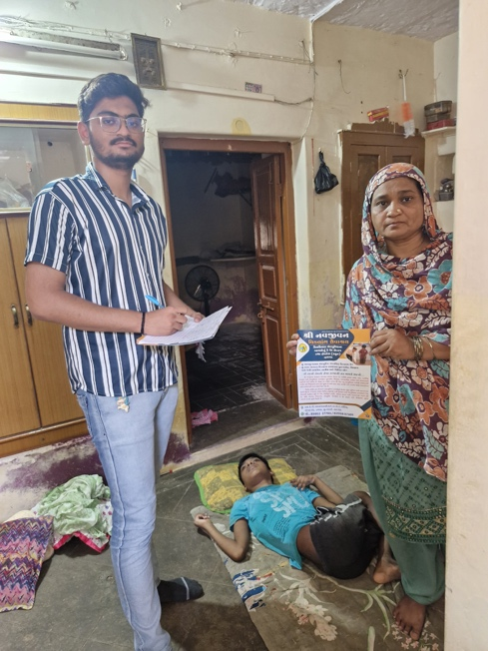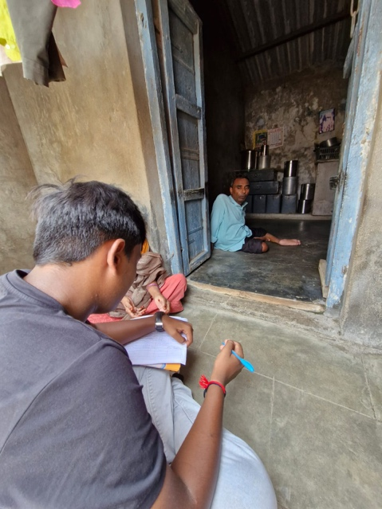
- Community Outreach on Inclusive Rights
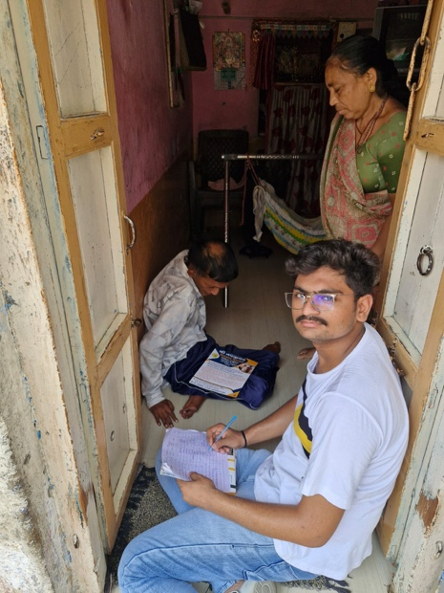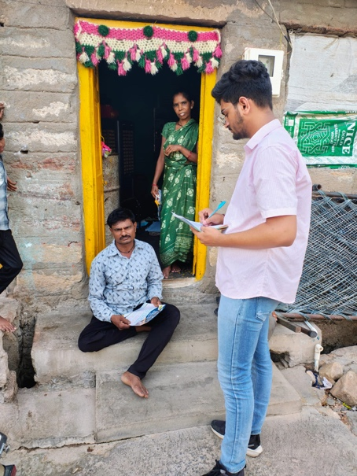

- Group Photo with NGO Volunteers
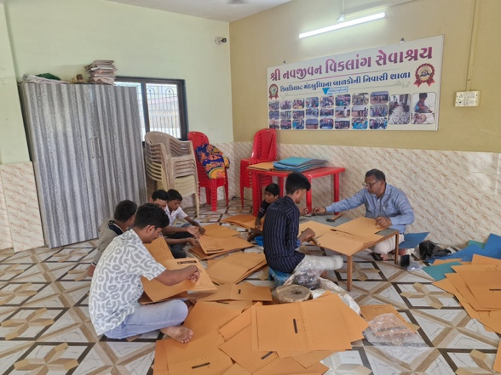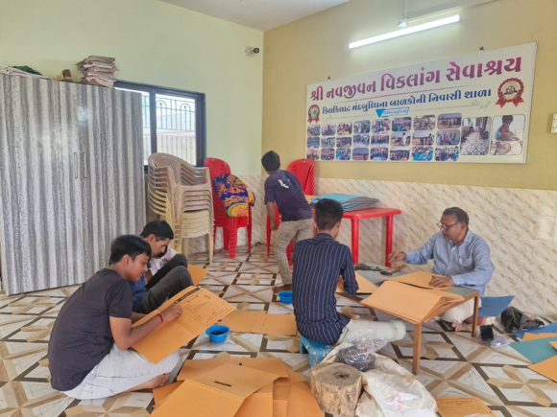

Beneficiaries of Activity from Community/City/Village:
- Physically and mentally disabled children and adults in Dhrangadhra
- Families who were unaware of government schemes and eligibility criteria
- Community members who gained better awareness about inclusion
- NGO, which received updated and structured data for follow-up action

Identification of the problems associated with the concern community/NGO:
- Lack of awareness about disability benefits and available schemes.
- Many individuals did not have a disability card or knew how to apply for one.
- Stigma and social exclusion still prevalent in certain areas.
- Some families were hesitant to come forward or lacked documentation.
- The NGO had limited manpower to cover large areas for outreach.

Technical Solution proposed:
- Recommended creation of a digital database to maintain records of disabled individuals in the town.
- Suggested collaboration with local government offices for faster processing of disability cards.
- Proposed simplified pamphlets or posters in local language to educate families.
- Use of WhatsApp groups to send reminders and updates about schemes.
- Encourage involving school/college volunteers in data collection and awareness drives.

Impact of Activity for Societal Benefit:
- Direct support to over 80+ families in identifying and applying for disability benefits.
- Helped raise awareness in the community about government schemes.
- Strengthened the NGO’s outreach efforts with updated data.
- Reduced misinformation and stigma among people about disabilities.
- Empowered families to take further steps towards formal support and inclusion.

Concluding Remarks:
- This community service was a deeply humbling and eye-opening experience.
- I learned the importance of fieldwork, compassion, and clear communication while working with sensitive communities.
- Every interaction helped me understand the struggles and resilience of specially-abled individuals.
- I’m proud to have contributed meaningfully by connecting more than 80 people to possible government support.
- I hope to continue supporting inclusive practices and social awareness in any way I can.

